Exploratory Data Analysis Insights
Summary Statistics
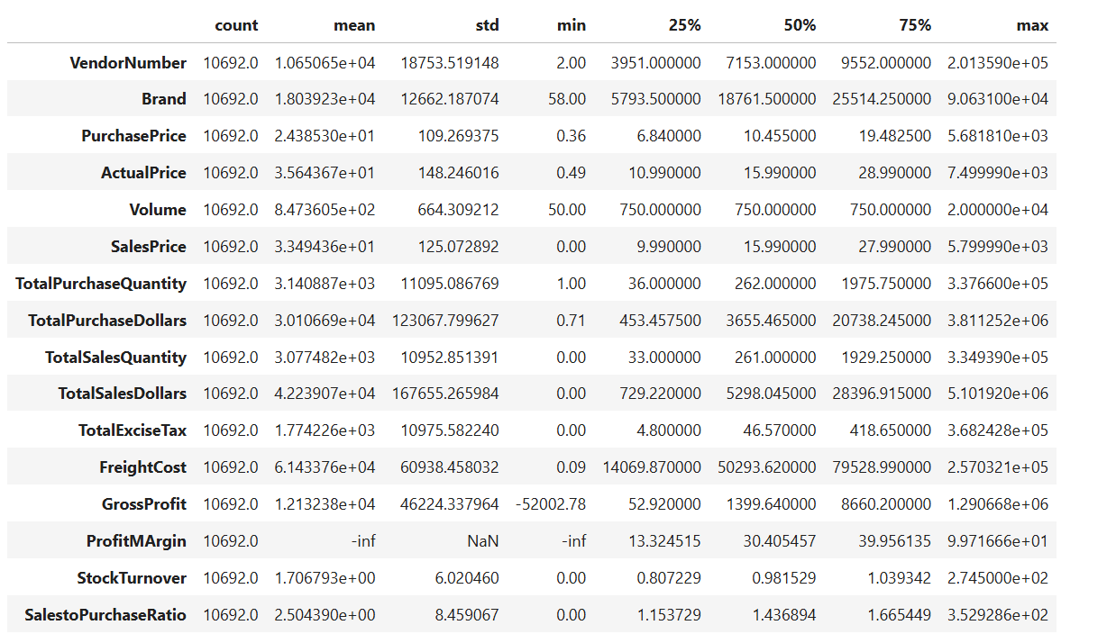
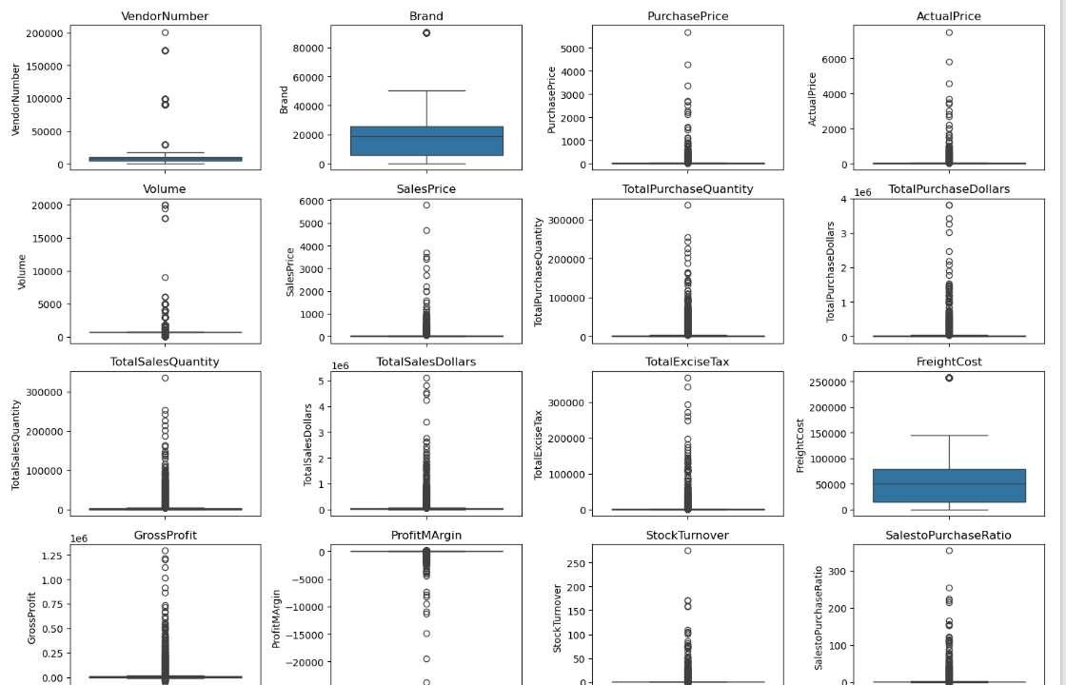
Negative & Zero Values:
Gross Profit: Minimum of -52002.78, indicating potential losses due to high costs or heavy discounts. This could be due to selling products at lower prices than their purchase costs.
Profit Margin: Has a minimum of -∞ which suggests instances where revenue is zero or even lower than the total cost, leading to extreme negative profit margins.
Total Sales Quantity & Sales Dollars: Some products show zero sales, indicating they were purchased but never sold. These may be slow-moving or obsolete stock, leading to inventory inefficiencies.

Outliers Detected by High standard deviations:
Purchase & Actual Prices: The maximum Values (5681.81 & 7499.99) are significantly higher than the mean (24.39 & 35.64), indicating premium products offerings.
Freight Cost: Extreme variation from 0.09 to 257,032.07 suggests logistics inefficiencies, bulk shipments or erratic shipping costs across different products.
Stock Turnover: Ranges from 0 to 274.5, suggesting some products sell rapidly while others remain unsold for long periods. A value greater than 1 indicates that sales for a product exceed the purchase quantity due to older stock fulfilling orders.

Data Filtering
To Enhance the reliability of the insights, we removed inconsistent data points where:
- Gross Profit ≤ 0 (to exclude transaction leading to losses).
- Profit Margin ≤ 0 (to ensure analysis focuses on profitable transactions).
- Total Sales Quantity = 0 (to eliminate inventory that was never sold).

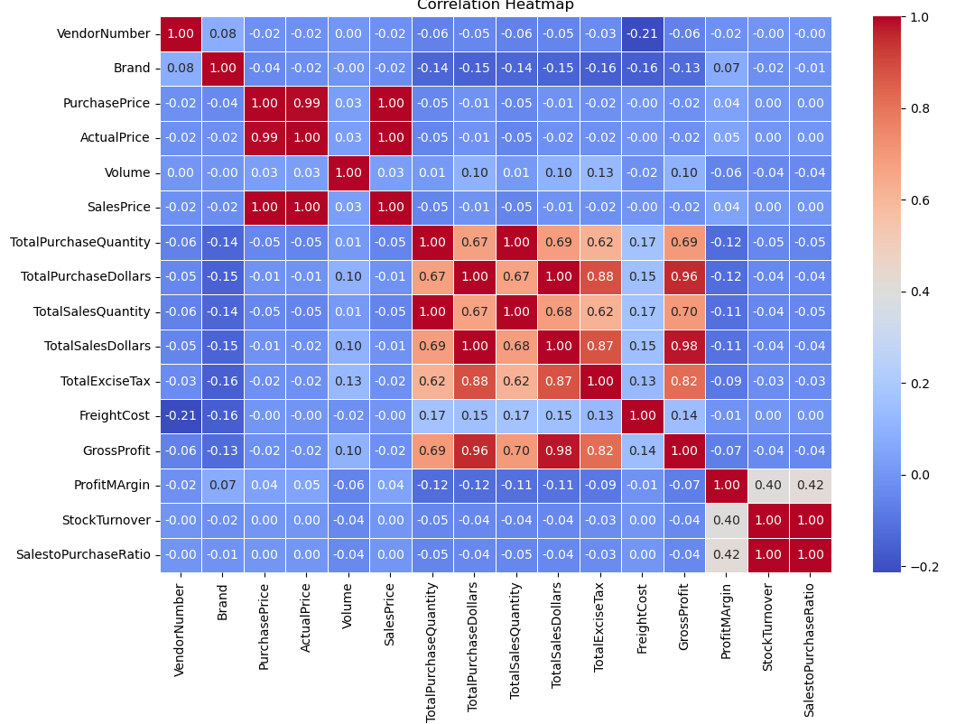
Purchase Price Vs. Total Sales Dollars & Gross Profit: Weak Correlation (-0.01 and -0.02), indicating that price variation do not significantly impact sales revenue or profit.
Total Purchase Quantity Vs. Total Sales Quantity: Strong Correlation (1.00), confirming efficient inventory turnover.
Profit Margin Vs. Total Sales Price: The correlation is very weak and close to zero (0.04), it suggests changes in total sales price do not meaningfully affect profit margin.
Stock Turnover vs. Gross Profit & Profit Margin: Stock Turnover has a positive impact on Profit Margin (+0.40) but almost no or slightly negative correlation with Gross Profit (–0.04), it suggests High-turnover products could have moderate prices but strong margins (due to low costs) and Low-turnover products might be high-value but costly, boosting total gross profit but lowering margin %.

Research Questions & Key Findings
- Brands For Promotional or Pricing Adjustments

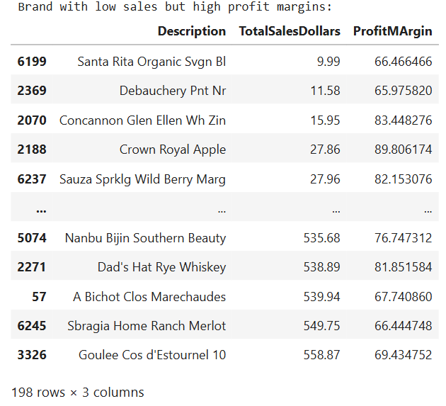
198 brands exhibits lower sales but high profit margins, which could benefit from targeted marketing, promotions, or price optimization to increase volume without compromising profitability.
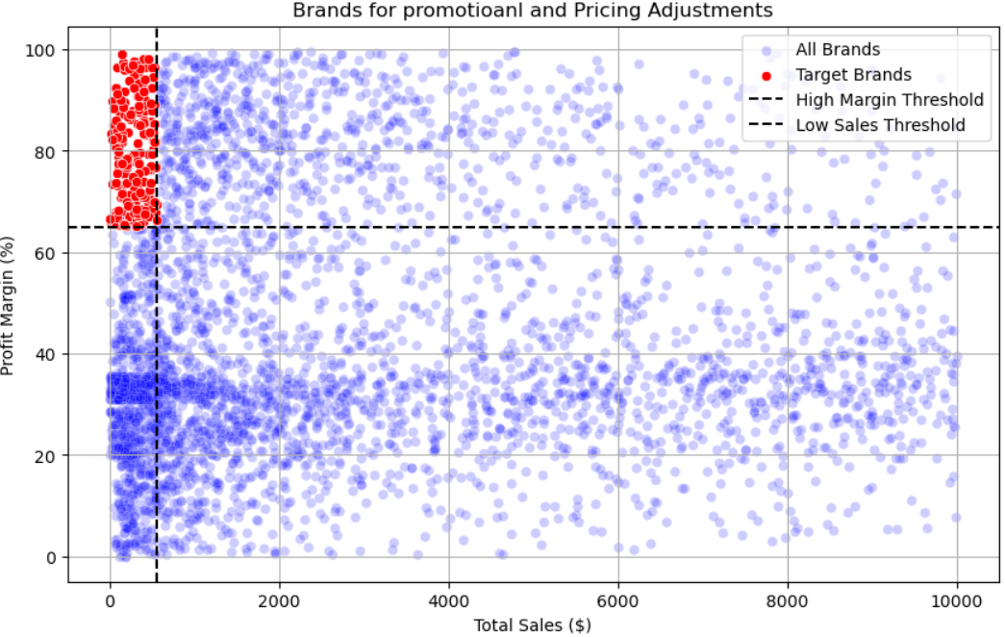
- Top Vendors by sales & purchase contribution
The top 10 vendors contribute 65.69% of total purchases, while the remaining vendors contribute only 34.31%. This over reliance on a few vendors may introduce risks such as supply chain disruptions, indicating a need of diversification.
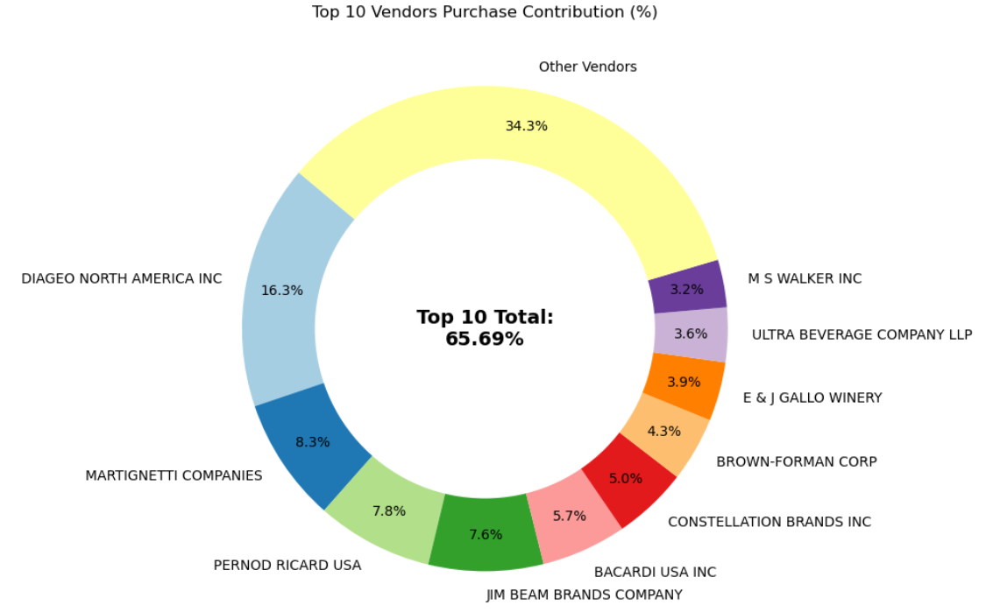

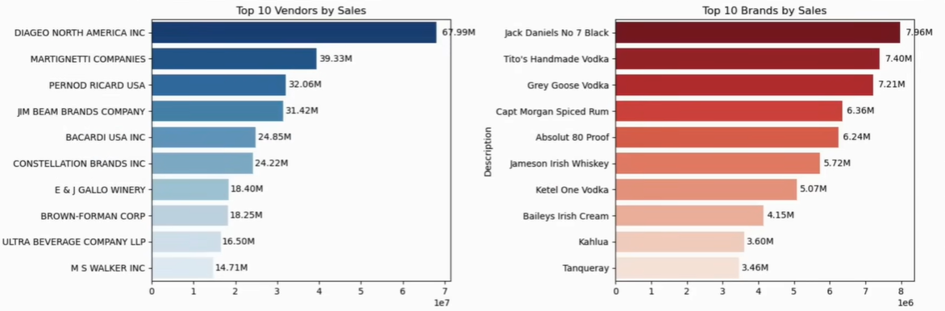
- Impact of bulk purchasing on cost savings
Vendors buying large quantities receive 72% lower unit cost ($10.78 per unit vs. higher unit costs in smaller orders).
Bulk pricing strategies encourage larger orders, increasing total sales while maintaining profitability.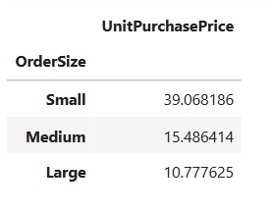

- Identifying vendors with Low inventory turnover
Total Unsold Inventory Capital: $2.71M
Slow-moving inventory increases storage costs, reduces cash flow efficiency and affects overall profitability.
Identifying vendors with low inventory turnover enables better stock management, minimizing financial strain.
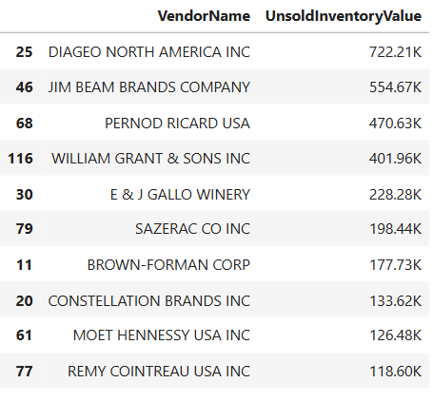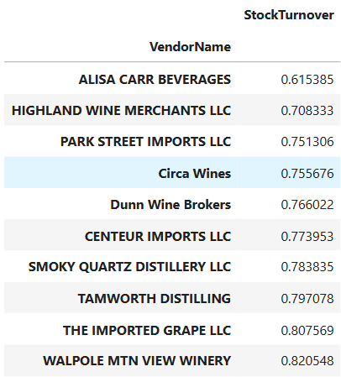

- Profit Margin Comparison: High vs. Low-Performing Vendors
Top Vendor’s Profit Margin (95% CI): (30.74%, 31.61%), Mean: 31.18%
Low Vendor’s Profit Margin (95% CI): (37.29%, 38.26%), Mean: 37.77%
Low performing vendors maintain higher margins but struggle with sales volumes, indicating potential pricing inefficiencies or market reach issues.
Actionable Insights:
- Top – Performing Vendors: Optimize profitability by adjusting pricing, reducing operational costs, or offering bundled promotions.
- Low – Performing Vendors: Improve marketing efforts, optimize pricing strategies and enhance distribution networks.
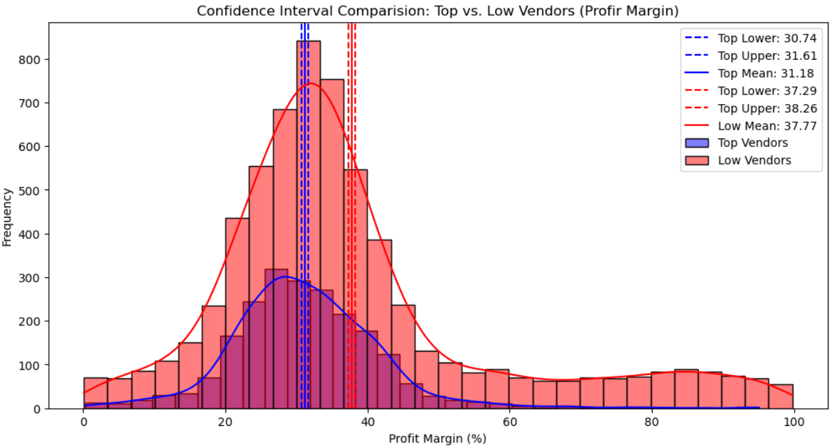
- Statistical Validation of Profit Margin Difference
Hypothesis Testing:
H₀ (Null Hypothesis): There is no significant difference in the mean profit margins of top-performing and low-performing vendors.
H₁ (Alternative Hypothesis): The mean profit margins of top-performing and low-performing vendors are significantly different.
Result: The null hypothesis is rejected, confirming that the two groups operate under distinctly different profitability models.
Implication: High-margins vendors may benefit from better pricing strategies, while top selling vendors could focus on cost efficiency

Final Recommendations
- Re-evaluate Pricing of low-sales, high margin brands to boost sales volume without sacrificing profitability.
- Diversify vendor partnerships to reduce dependency on few suppliers and mitigate supply chain risks.
- Leverage bulk purchasing advantages to maintain competitive pricing while optimizing inventory management.
- Optimize slow-moving inventory by adjusting purchase quantities. launching clearance sales or revising storage strategies.
- Enhance marketing and distribution strategies for low-performing vendors to drive higher sales volumes without compromising profit margins.
- By implementing these recommendations, the company can achieve sustainable profitability, mitigate risks and enhance overall operational efficiency.

